Geometry: Unit 5, Lesson 1
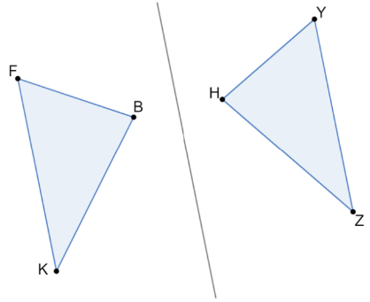
- $∆KBF$ and $∆ZHY$ are shown. $∆KBF$ was reflected across the line to create $∆ZHY$. What does $\overline{KB}$ map to?

$$\overline{HZ}$$

- Two triangles are considered what when the three sides of one triangle are congruent to the three corresponding sides of the other?

Congruent
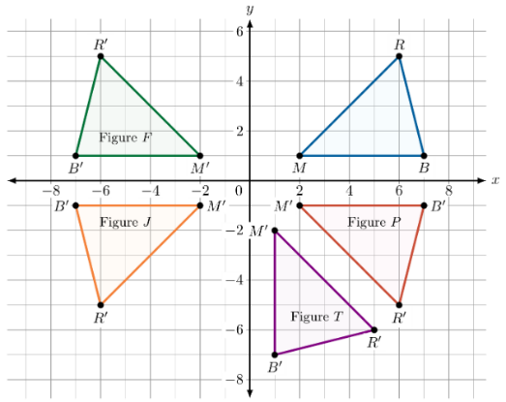
- Triangles $GBL$ and $HDT$ are shown, where $BG=7.2$, $DT=10$, $GL=12$, $HT=7.2$, and $DH=12$. Danielle can use paper or a protractor to determine if the triangles are congruent. What should she use and why?

Patty paper to determine if side $LB$ has the same length as side $DT$

